**Sync workspace emails with outlook-**

**Note: Step from 1 to 4 is done at the Admin Side and the Step 4 and 5 are done at the user side or users’ device.**

**Step-1** Go to Admin console account (<https://admin.google.com/ac/users?pli=1> )

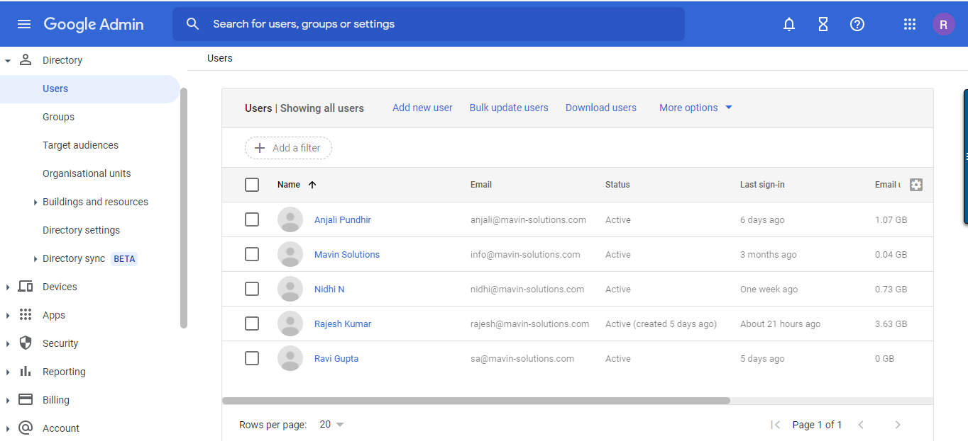

**Step-2** go toAccount**.**

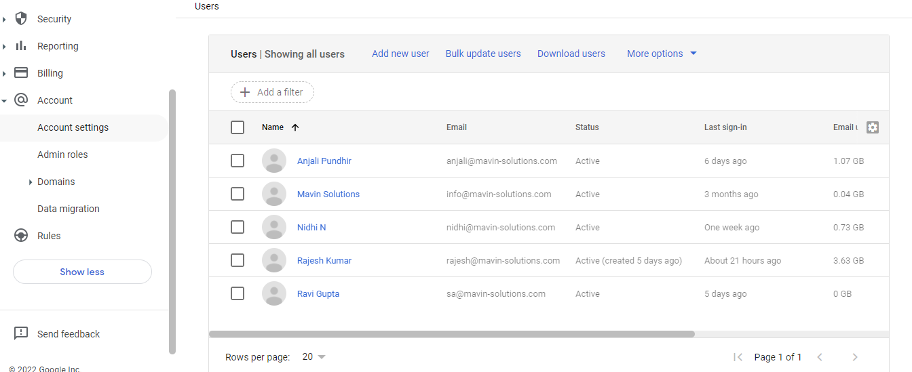

**Step -3** go to Data migration and add a user.

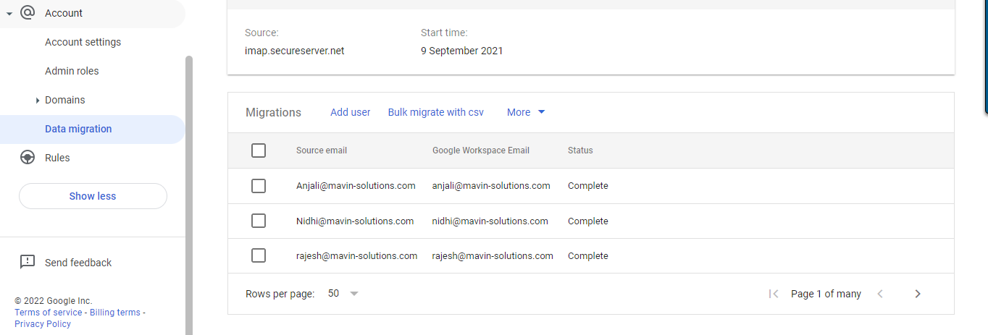

**Step -** 4 ADD the source email, Password, and workspace email.

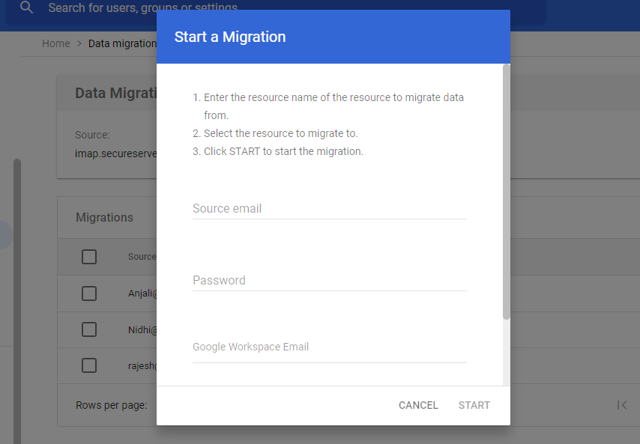

**Step –** 5 Download Google workspace sync for Microsoft **(**[**https://tools.google.com/dlpage/gssmo/**](https://tools.google.com/dlpage/gssmo/)**)**

Recommended for the user.

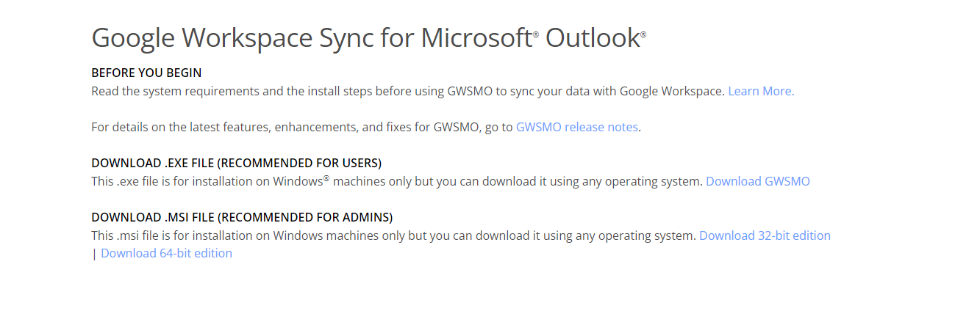

**Step - 6** install G suite and login with the workspace Email Idand login into outlook with the workspace then mails start to sync. (Remember outlook is not running in background during login into G suite)